NAME:______________________________

Fall Final Review Packet – PART 2

Instructions: Answer the following review questions. This packet will be worth a daily grade and will help you prepare for the final exam.

CULTURE

1. Define the following:

Culture --

Acculturation --

Assimilation --

Cultural Diffusion --

Cultural Hearth --

2. Fill in the following chart:
TERM | DEFINITION | EXAMPLES
Primary Economic Sector
Secondary Economic Sector
Tertiary
Economic Sector
Quaternary
Economic Sector

3. Fill in the following chart:
 | DEFINITION | TWO EXAMPLES

PUSH FACTOR

PULL FACTOR

4. What is the difference between EMIGRATION and IMMIGRATION?

5. What is CULTURAL CONVERGENCE? Name an EXAMPLE.

6. What is CULTURAL DIVERGENCE? Name an EXAMPLE.

LATIN AMERICA

7. How has COLONIALISM affected Latin America?

8. In what ways is Latin America an example of cultural convergence?

9. Why was Panama an excellent choice of location to build a canal to connect the Atlantic and Pacific Oceans?

10. Name three reasons that Brazil is unique in South America.
a.
b.
c.

11. What mountain range runs down the western coastline of South America?

12. Define the following:

Mulatto --

Mestizo –

13. What is the poorest country in Latin America?

14. What is the dominant religion in South America?

15. What is the only Communist country in Latin America?

16. What is the difference between Central, Middle, Latin, and South America?

17. Sustainability is a balance between what three things?

18. What does NAFTA have to do with globalization?

POPULATION GEOGRAPHY

19. What is the world’s approximate population?

20. What are some characteristics of the following (Use birth rate, literacy rate, life expectancy, etc…):

More Developed Country -

Less Developed Country –

21. What is the difference between subsistence farming and commercial farming?

22. What is GLOBALIZATION?

23. What do DEMOGRAPHERS study?

24. What is causing exponential population growth?

25. What do population pyramids measure?

26. Label the following RAPID GROWTH, SLOW GROWTH, and ZERO (OR NEGATIVE) GROWTH.

A B C
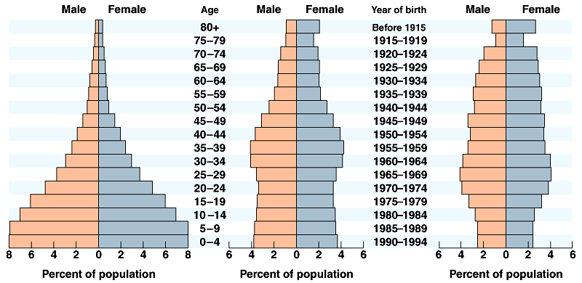

27. Which of the population pyramids above represents a LESS developed country?

28. Which one would you guess is the United States?

29. Which one would you guess is Kenya?

30. Which one would you guess is Italy?

31. What is the difference between standard of living and quality of life?

32. What is infrastructure?

GOVERNMENT AND ECONOMY

33. Define the following political systems and give an example of a country that uses (or used) it:
DIRECT DEMOCRACY  EX. | REPUBLIC  EX. | MONARCHY  EX.
COMMUNIST  EX. | DICTATORSHIP  EX. | THEOCRACY  EX.

34. Define the following economic systems and give an example of a country that uses (or used) it:
FREE ENTERPRISE  EX. | TRADITIONAL  EX.
COMMAND  EX. | MIXED  EX.

35. Match the following political systems to the appropriate economic systems:

DEMOCRACY COMMAND ECONOMY

COMMUNISM FREE ENTERPRISE

36. Name an example of a renewable resource

37. Name an example of a nonrenewable resource.

EUROPE/RUSSIA

38. What are three ways Europe’s geography gives it an advantage?
1.
2.
3.

39. How is East Europe a CULTURAL CROSSROADS?

40. What is the EU and how is it working to UNITE Europe?

41. Which two countries have broken apart to create smaller countries since WWII in Europe?

42. What is nationalism and how has it contributed to the rise of nation-states in Western Europe?

43. Where was democracy first founded?

44. Which two countries are in the IBERIAN PENINSULA?

45. Why is the ARAL SEA shrinking?

46. What is the meaning of the phrase “the sun never sets on the British Empire”?

47. What four regions are found in the United Kingdom?

48. What is GREAT BRITAIN?

49. Who are the ROMA? How have they been treated in Europe?

50. What are SATELLITE NATIONS and how did the U.S.S.R. use them?

51. What is ACID RAIN and how is it affecting the forests of Europe?

