NAME:______________________________

FALL FINAL REVIEW PACKET

Instructions: Answer the following review questions. This packet will be worth 2 daily grade and will help you prepare for the final exam. This packet is due the day of your final.

UNIT 1

1. What are the 5 themes of Geography? Give 2 examples of each.

a.

b.

c.

d.

e.

2. What is the difference between relative and absolute location? Give an example of each.

3. What is Geography? What are geographers most interested in studying?

4. What is the difference between cultural and physical descriptions of place? Give an example for each.

a. Cultural

b. Physical

5. How do map projections distort?

6. What are the elements of a map (TODALS)?

7. Fill out the following chart:

 | Significant Lines: | Lines are also called: | Direction measures:
Latitude
Longitude
8. What does GIS stand for? What is GIS?

9. What city does the Prime Meridian run through?

10 What ocean does the International Date Line run through?

11. What is a region?

12. Give an example of each of the following:
Perceptual Region __________________________
Formal Region _____________________________
Functional Region __________________________

UNIT 2

13. What creates the seasons?

14. What is an “Equinox?” Which two seasons experience an “Equinox?”

15. What is a Solstice? Which two seasons experience a Solstice?

16. How do the Southern and North Hemispheres affect season?

17. What do the Tropic and Cancer and Tropic of Capricorn have to do with seasons?

18. On which day does Austin, Texas get the most sunlight?

19. On which day does Austin, Texas get the least sunlight?

BE SURE YOU STUDY YOUR SEASONS CHART!!!

20. What are 8 main controls on climate? (think LACEMOPS!) Briefly explain how each affects climate.

L

A

C

E

M

O

P

S

21. Which control on climate is the most important (has the biggest influence)?

22. What relationship does altitude have with temperature?

23. What two things do climographs measure?

24. In the boxes below, draw what each climograph might look like.
Desert in the Northern Hemisphere | Tropical Wet (on the equator) | Southern Hemisphere with wet summers, dry winters | North Hemisphere with continentality and little rain

25. What is the orographic effect?

Draw an illustration of the orographic effect below. Label your illustration using the following words: windward, leeward, rain shadow

26. What is the difference between climate and weather?

27. Match the following to the correct climate region and fill in vegetation:

POLAR MIDDLE LATITUDES - Describe vegetation-___________________________

TEMPERATE LOW LATITUDES - Describe vegetation-______________________________

TROPICAL HIGH LATITUDES - Describe vegetation-______________________________

28. How is carbon related to global warming?

29. Draw the Greenhouse Effect in the space below:

30. Give 2-3 major characteristics of the following climate regions:

subarctic

arctic

semiarid

desert

marine west coast

tundra

tropical wet

tropical wet and dry

Mediterranean

Humid subtropical

Humid continental
UNIT 3

31. Define the following:

Culture --

Society --

Ethnic Group –

Standard of Living

32. Who are the BRIC countries and what are their developmental characteristics?

33. Fill in the following chart:
TERM | DEFINITION | EXAMPLES
Primary Economic Sector
Secondary Economic Sector
Tertiary
Economic Sector
Quaternary
Economic Sector

34. What is the world’s approximate population?_________________________

35. What is the difference between subsistence farming and commercial farming?

36. What do DEMOGRAPHERS study?

37. Why are some places sparsely populated while others are densely populated?

38. What is causing exponential population growth?

39. What do population pyramids measure?

40. Label the following RAPID GROWTH, SLOW GROWTH, and ZERO (OR NEGATIVE) GROWTH.

A B C
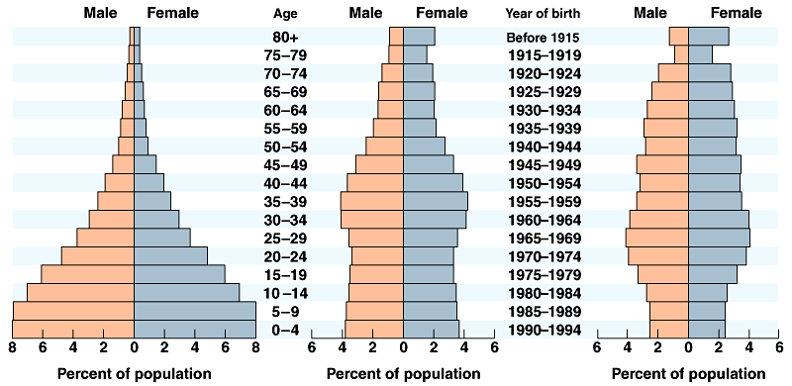

41. Which of the population pyramids above represents a LESS developed country? ________________

42. Which one would you guess is the United States? ____________________________

43. Which one would you guess is Kenya? ____________________________

44. Which one would you guess is Italy? ____________________________

45. What is the difference between standard of living and quality of life?

46. What is infrastructure?

47. Fill in the following using development terms (life expectancy, birth rate, literacy rate, economic sectors, infrastructure, etc..)

Unit 4

48. Fill in the following chart on Plate Tectonics:
Plate Boundary | Drawing/Illustration | Is lithosphere Created, Destroyed or Neither?
CONVERGENT
DIVERGENT
TRANSFORM

49. Draw a picture of the following landforms:
ARCHIPELAGO |  | BASIN
CAPE |  | DELTA
GLACIER |  | ISTHMUS
MESA |  | PENINSULA
PLAIN |  | PLATEAU
TRIBUTARY |  | STRAIT

50. What is the difference between an isthmus, a strait, and a canal?

51. Describe Internal and External Forces that shape the Earth.

52. What is the difference between weathering and erosion?

53. What is the difference between a mesa and a plateau?

54. Draw a symbol to represent the following layers of Earth.
LITHOSPHERE | BIOSPHERE | ATMOSPHERE | HYDROSPHERE

