Global News Log
Instructions: Report on six different current events by searching articles within appropriate international news sources. Each article should be from a different region (see regions below). Read the article carefully and then fill out the chart. To show location, color the country on the map below and the square in the chart for the corresponding article with the same color. Decide which geographic theme best fits with the article and write a three-line summary. Write the news article title, source, and author in the source line.
Suggested News Sources | Regions (use one for each article) | Geographic Themes
CNN International  BBC News  New York Times  NPR | U.S. & Canada  Europe (including U.K.)  Latin America  Africa  Asia & Oceania  Middle East | Environment (Including HEI)  Geopolitics & Government  War and Conflict  Population  Economics  Food and Agriculture  Natural Resources  Culture

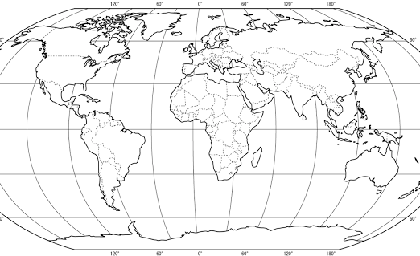

Global News Log
 | KEY | ARTICLE SOURCE AND INFORMATION
ARTICLE 1 | Location: | Title and Author:______________________________________________________ Source: __________________  Date: ____________________________________ Geographic Theme:___________________________________  Summary: _________________________________________________________________________________________  _____________________________________________________________________________________________________  _____________________________________________________________________________________________________
ARTICLE 2 | Location: | Title and Author:______________________________________________________ Source: __________________  Date: ____________________________________ Geographic Theme:___________________________________  Summary: _________________________________________________________________________________________  _____________________________________________________________________________________________________  _____________________________________________________________________________________________________
ARTICLE 3 | Location: | Title and Author:______________________________________________________ Source: __________________  Date: ____________________________________ Geographic Theme:___________________________________  Summary: _________________________________________________________________________________________  _____________________________________________________________________________________________________  _____________________________________________________________________________________________________
ARTICLE 4 | Location: | Title and Author:______________________________________________________ Source: __________________  Date: ____________________________________ Geographic Theme:___________________________________  Summary: _________________________________________________________________________________________  _____________________________________________________________________________________________________  _____________________________________________________________________________________________________
ARTICLE 5 | Location: | Title and Author:______________________________________________________ Source: __________________  Date: ____________________________________ Geographic Theme:___________________________________  Summary: _________________________________________________________________________________________  _____________________________________________________________________________________________________  _____________________________________________________________________________________________________
ARTICLE 6 | Location: | Title and Author:______________________________________________________ Source: __________________  Date: ____________________________________ Geographic Theme:___________________________________  Summary: _________________________________________________________________________________________  _____________________________________________________________________________________________________  _____________________________________________________________________________________________________

