Who lives where and why?

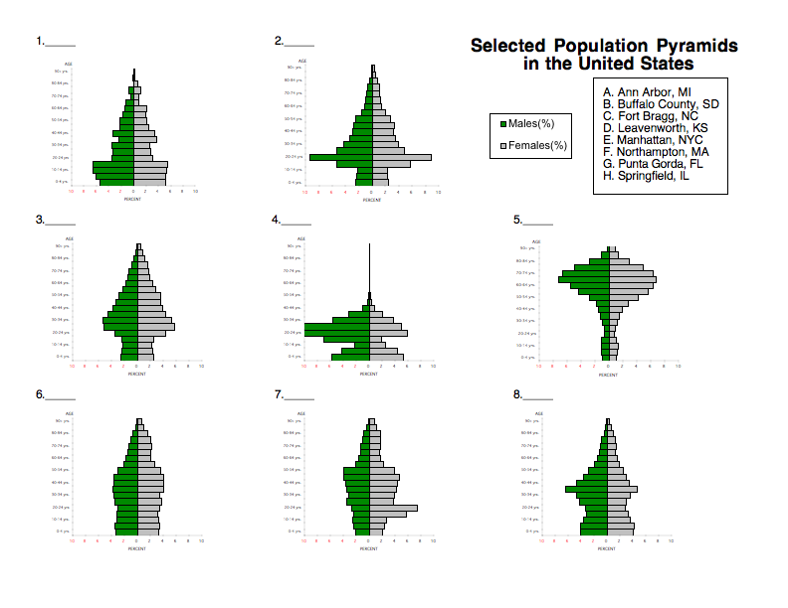Using the information below, please match the population pyramids with their correct locations.

Germantown - wealthy suburban area: There are very few people in their 20’s living in this region. The reason for this is that this zip code has very high residential housing costs. The people who live here usually move into the zip code so that their children (ages 5-18) can attend the public schools in Germantown. The reason there are so few people over the age of 60-65 is that people will move out of this area and retire in other more desirable areas.

Bartlett - older suburban area: This area is a well established zip code where many people have raised their families and plan on retiring in the area as well. As a result the schools were much larger in the 1980’s and 90’s. In fact the schools in the area have had to surplus some of their teachers to areas in the county where growth is higher.

East Memphis - one of the older wealthiest residential areas: This is one of the most sought-after areas in Memphis in which to live. It is also an area with retirement facilities, which usually have more women than men (since women do have a higher life expectancy than men).

Downtown Memphis - few families, correctional center: The downtown zip code is not the most desirable area in which to raise a family. There are few schools, parks, or facilities that cater to children, and the overall environment is not “child friendly.” It is an area that is better suited for young professionals. This area also has a prison at 201 Poplar Avenue. Most people in Memphis would know that if you say “201 Poplar” you are talking about the jail in downtown.

University of Memphis - residential area with large numbers of university students: The University of Memphis has many students who commute to campus and do not live near the university. However, there are enough students living on and near campus for it to show up on the population pyramid.

South Memphis - one of the poorest areas in Memphis: This zip code in Memphis has a per capita income (1999 dollars) of $13,798. The median value of a home is only $68,900. Only 10.5% of the population has a Bachelors degree or higher. As a result of the poverty and lack of education, the life expectancy is lower and the birth rate is higher.

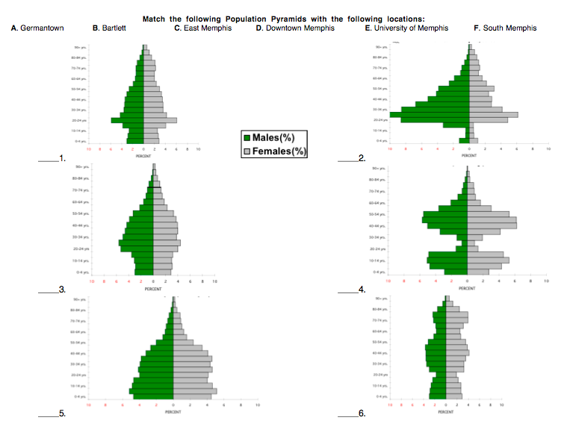

Analysis and evaluation
With the population pyramids displayed on the wall discuss the differences between the population pyramids in different areas of the county.

Why are there differences?

Where in the county is it wealthy? Poor?

Where in the county is the population the youngest? Oldest?

How do the suburbs differ from the inner city?

